Inspecting Data Meerkat:

Just as a test if I can download the Meerkat MGCLS DR1 dataset, I downloaded 3 images: Abell_133_aFix_pol_I_15arcsec_fcube_cor.fits, Abell_133_aFix_pol_I_Farcsec_fcube_cor.fits and Abell_133_aFix_pol_Q_Farcsec_fcube_cor.fits

Some notes about my quick inspection:

* I quickly saw that the 15arcsec version has lower angular resolution 🡪 probably a convoluted version of the Farcsec version
* Many sources >500 are visible in the I channel
* Less sources ~30 are visible on the Q channel, not bad!
* 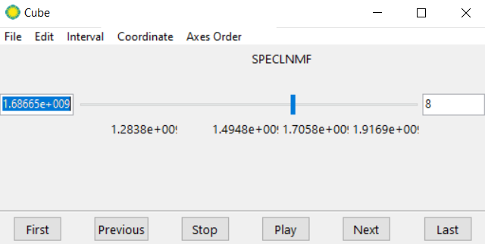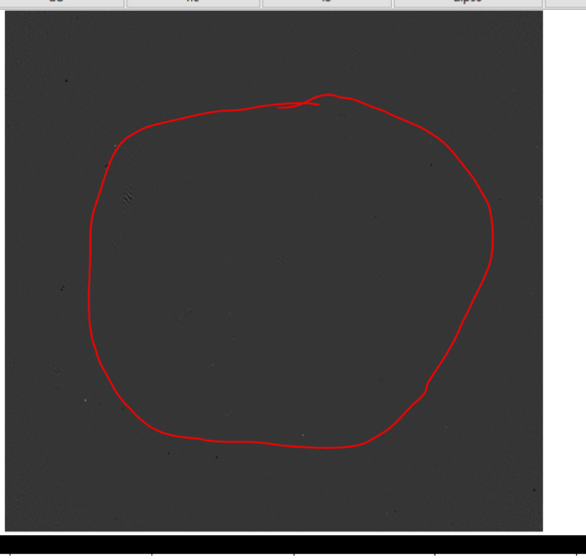On the Q channel image 8, a perfect ring is present of hot pixels, spanning the whole image. This is not normal. This is visible on more than one image and the circle changes radius depending on the frequency
* On the Q channel, some sources are darker than background while others are lighter than the background. This is completely normal!
* 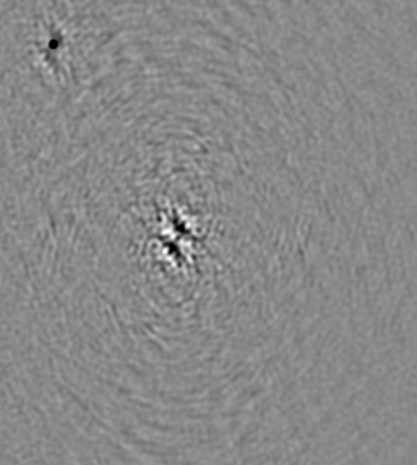The artifacts around bright sources become very dominant in the Q channel. On the image below, upper left is normal source, middle is artifact.

A match was searched between the available Meerkat and Eriks VLA polarization data

Three objects were found to overlap:

1. Abell_85 = G115.16-72.09 = MATCH has 18 Eriksources
2. Abell_209 = G159.85-73.47 = MATCH has 5 Eriksources, only I,U,V, Q is missing
3. Abell 133 = G149.55-84.16 = MATCH has 1 Eriksource

**We look at Abell 85 in I, Q, V and U:**

We see that there are about 20 sources of polarization findable in the Q-channel.

If we take a look at one such source, we see that there is also quite some polarization visible in the U channel and some artifacts in V, but no source in V as expected. This is at the longest wavelength. All polarization channels are scaled the same from -0.0005 to 0.0005 Jy/beam. I channel is scaled differently and logarithmically.

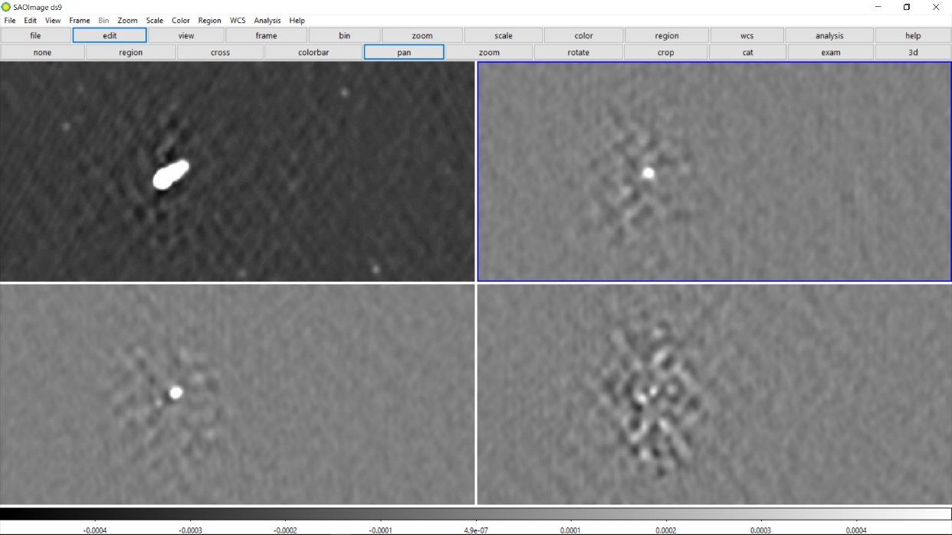

However, as we decrease the wavelength, a source becomes visible in V also. At image 8-9, we get a negative source in V, at 10 none and at 11-12 a positive source. How is this possible? Below an image with all frames at the 12th shortest wavelength:

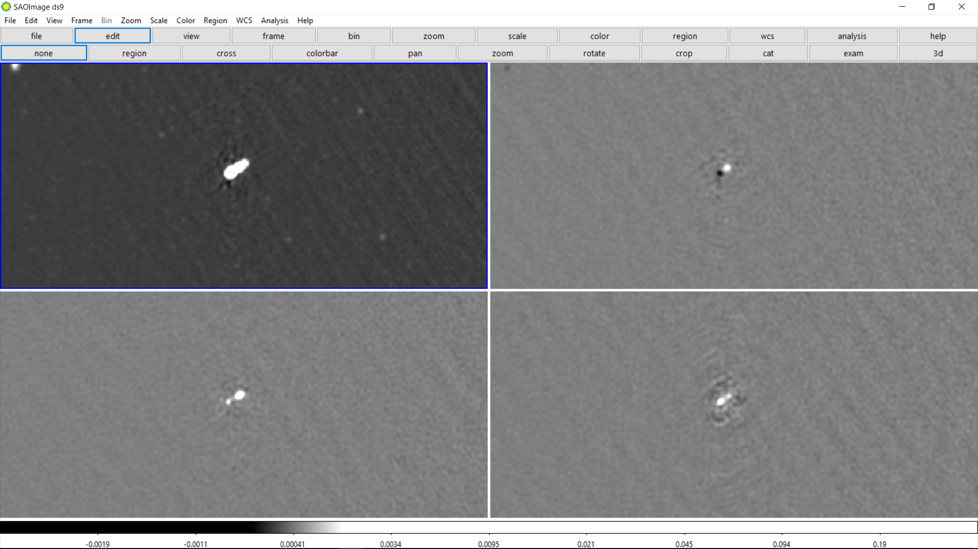

This is very strange. Moreover, the amount of circular polarization is in the **same order** as the linear polarization channels. I find this suspicious, as AGNs generally are NOT circularly polarized. It is checked if this is the same for other sources.

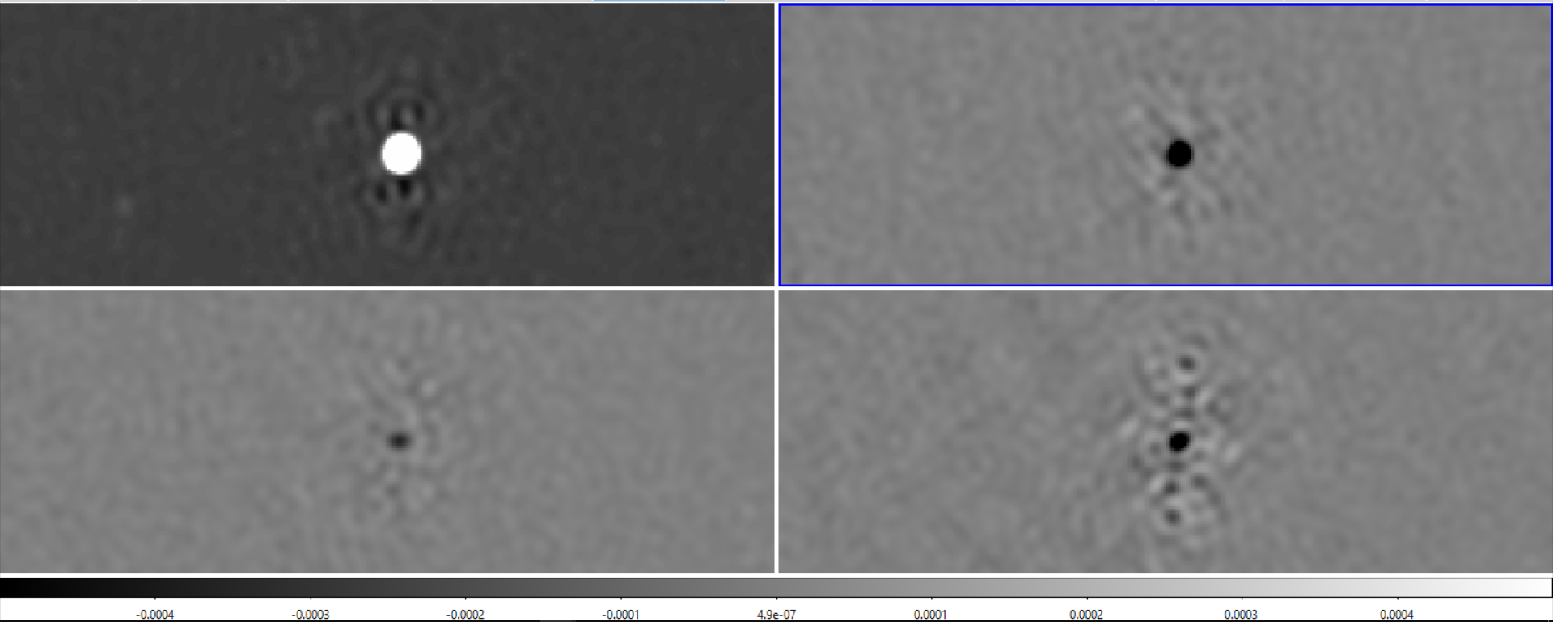

This other bright source has the same thing going on. But what about dimmer sources?

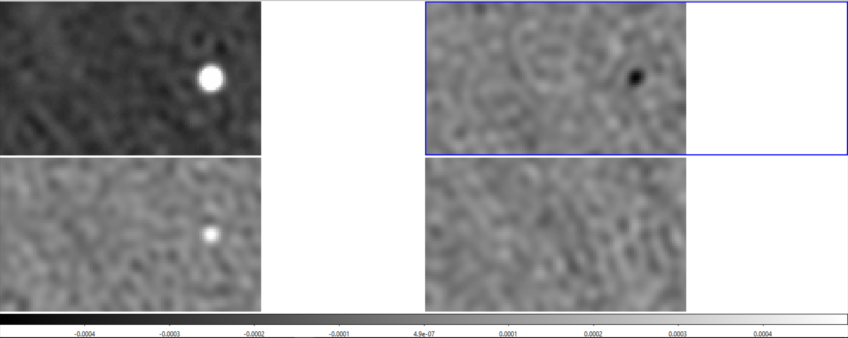

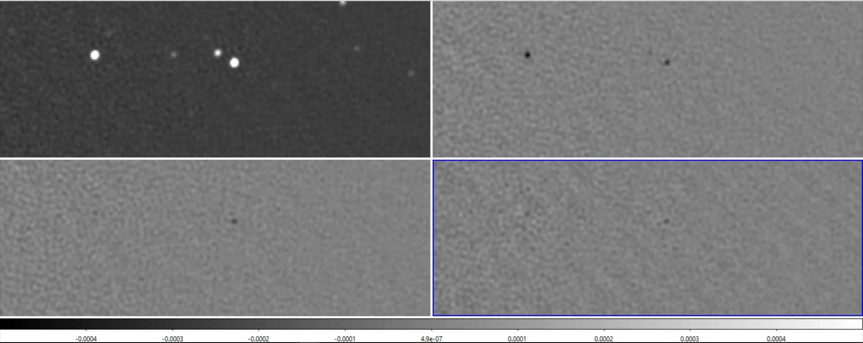

The dimmer point sources have no circular component, it looks as if circular polarization only is visible when intensity is very large at certain beams 🡪 I suspect leakage. Linear polarization could be result of leakage instead of sources themselves.

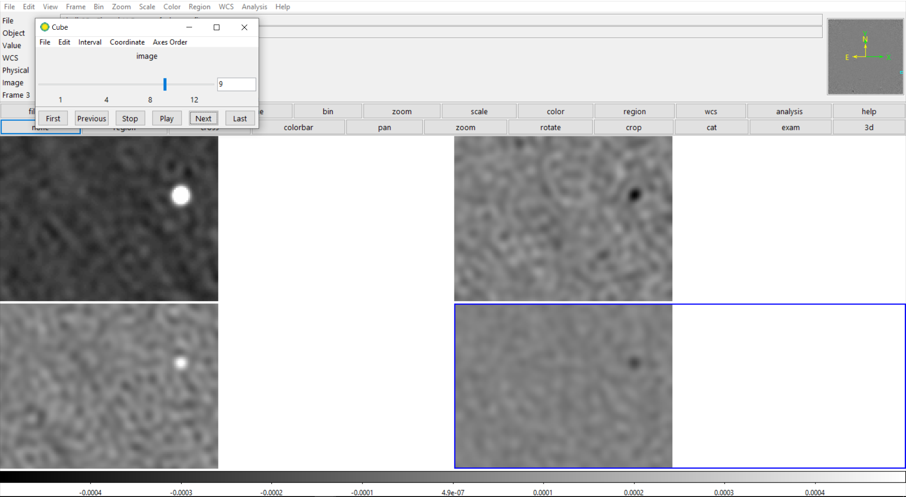

**Note:** at wavelength image 9, there seems to be a signal in V for both dimmer sources, all other wavelengths show nothing.

These same dim sources generally only show polarization at short wavelengths, not at longer ones. I found a dimmer source that remains polarized at all wavelengths though.

What about resolved sources of polarization?

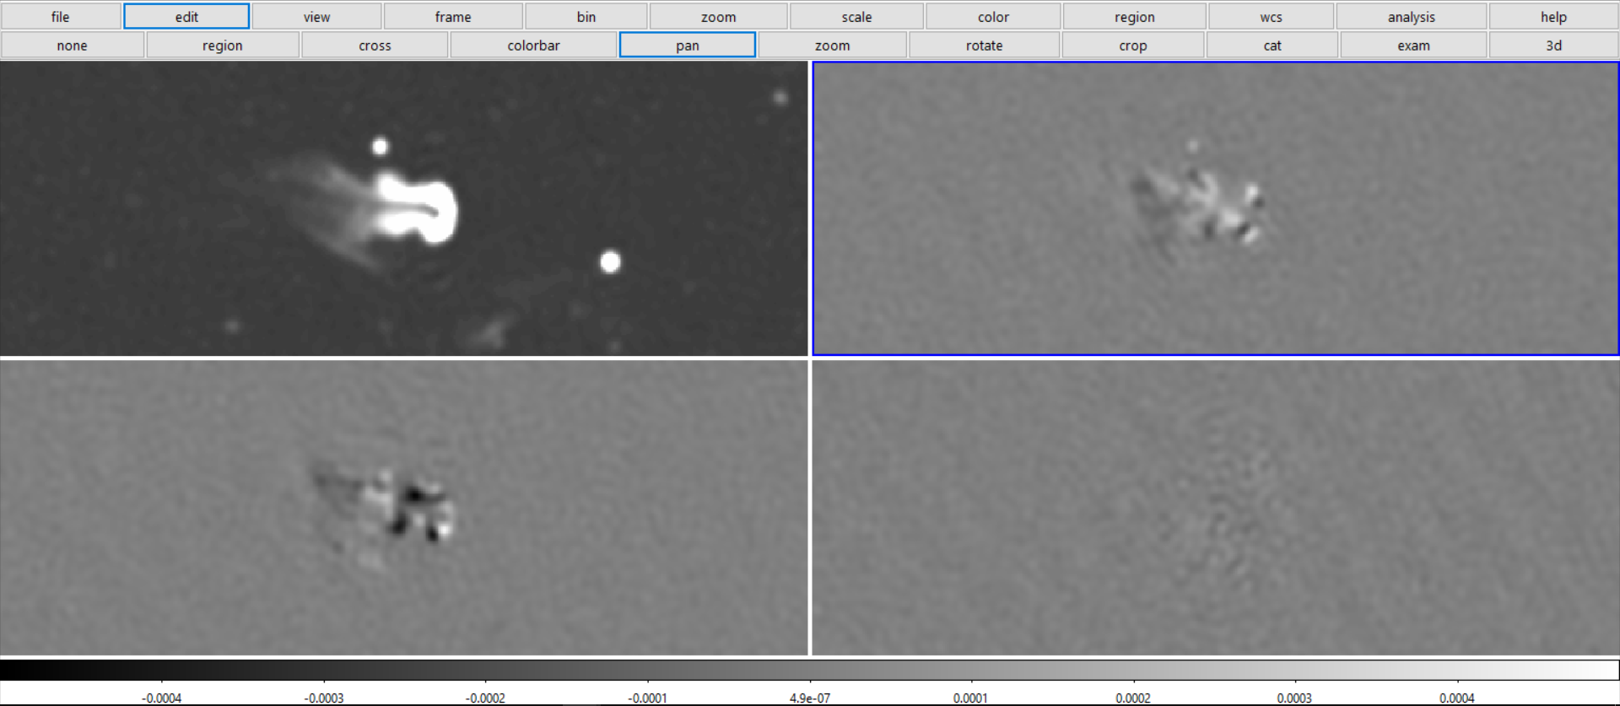

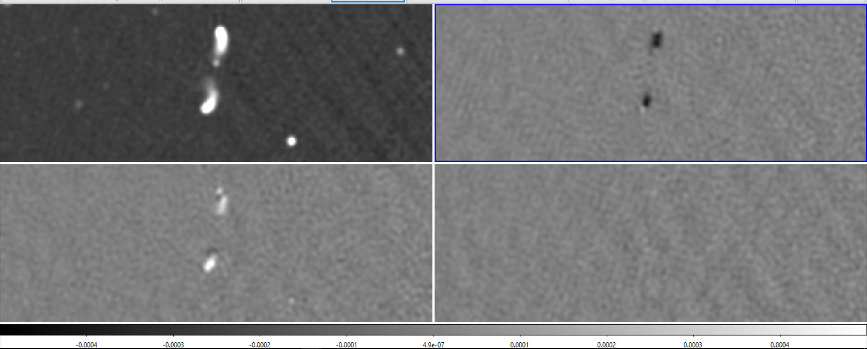

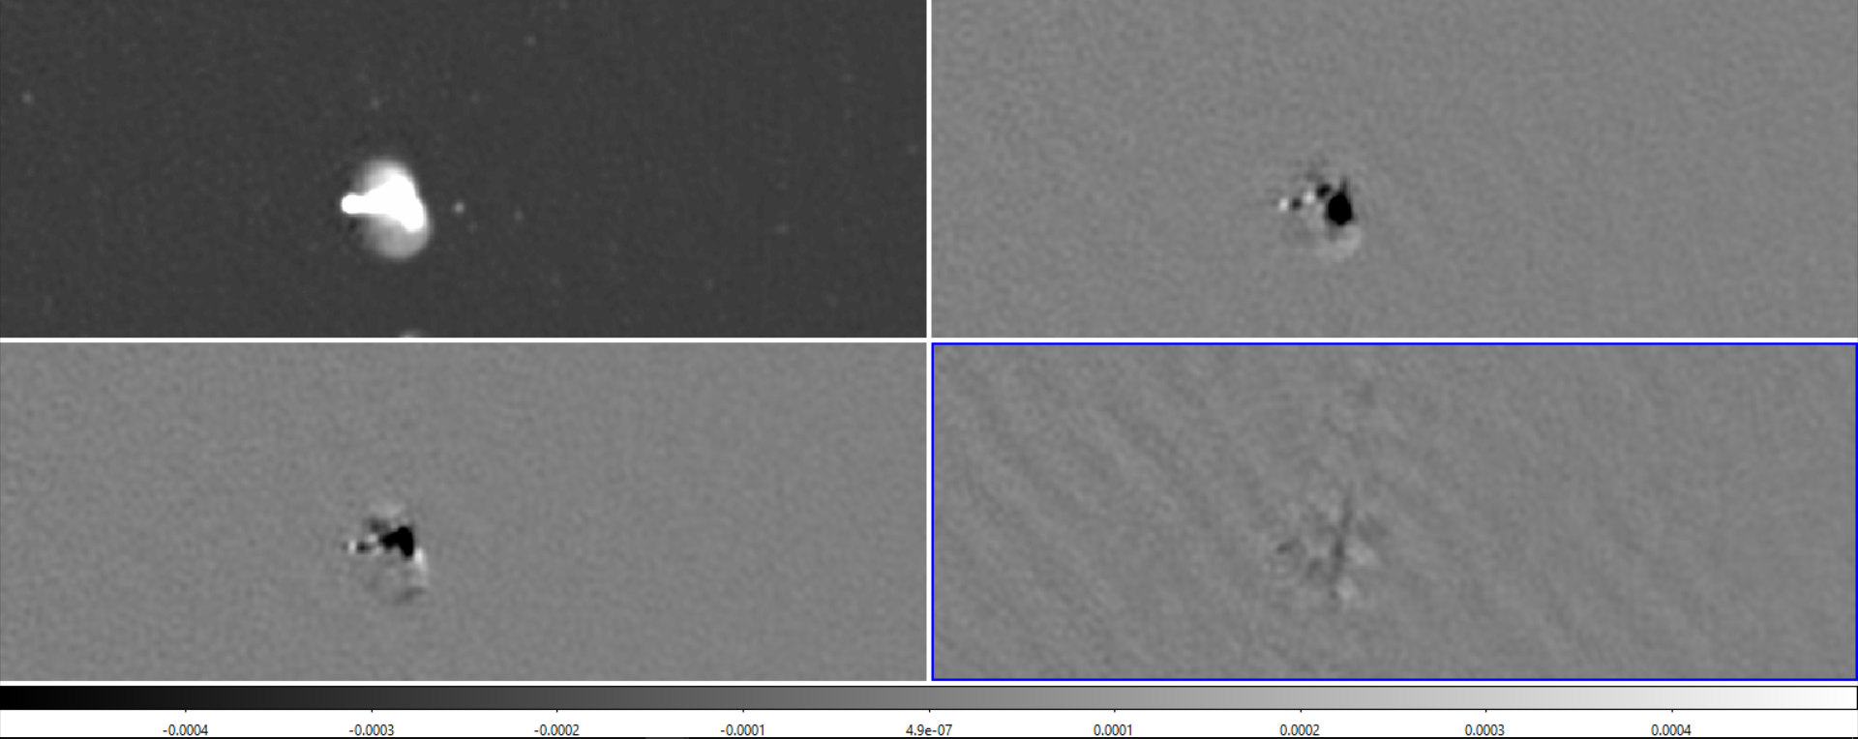

For all the above diffuse resolved sources, we don’t see the same pattern. We see linear but no circular polarization. For these resolved sources, no circular polarization is seen over the whole spectrum range (apart from some very weak diffuse structures).